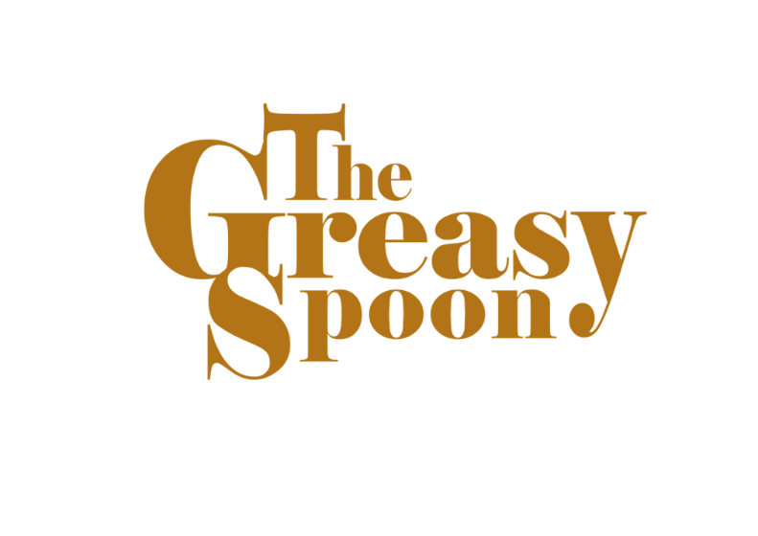

**„…it’s only Rock’n’Roll!“ (EP)**

**From March 15th, available on music platforms everywhere!**

For all those in search of a musical experience that combines good vibes, infectious rhythms, and plenty of funk elements, we have some exciting news: The Greasy Spoon, the hottest funk-rock band of the season, has just released their first EP in over 10 years!

The EP, titled "…it’s only Rock’n’Roll" is an honest expression of pure musical energy and passion. The band has added a new drummer, injecting fresh vitality into their already impressive sound. The rhythms are funkier than ever, the guitar riffs have an extra bite, and the lyrics promise good times and the spirit of rock 'n' roll. And yes, there are harmonica solos (you read that right) that add a unique touch, showcasing the spooners’ versatility.

The EP is a sincere expression of pure musical energy and passion. It features a total of 5 captivating tracks, including the groovy "Claude’s Café," which immediately immerses listeners in the world of The Greasy Spoon. Other tracks like "Take Me As I Am," the bluesy "Station Girl," and the title track "The Stars" will undoubtedly keep the party going. And the ballad "She’s Dancing" strikes right at the parental heart.

The band is excited to perform their new tracks live on various stages and at festivals. Fans of feel-good rock and funk enthusiasts shouldn't miss this opportunity.

"…it’s only Rock’n’Roll" is now available on all major music platforms. Crank up the volume, let the grooves carry you away, and celebrate with The Greasy Spoon!

For interviews, booking inquiries, and additional information, the band is readily available.

* Homepage:  [www.the-greasy-spoon.de](http://www.the-greasy-spoon.de)
* Instagram: <https://www.instagram.com/thegreasyspoonband>
* Facebook: <https://www.facebook.com/thegreasyspoonband>
* Youtube: <https://www.youtube.com/@TheGreasySpoonBand>
* TikTok: <https://www.tiktok.com/@thegreasyspoonband>
* Mail:[thegreasyspoon@gmail.com](mailto:thegreasyspoon@gmail.com)